- Navigation Explorer
List and navigate to table lists from anywhere in model-driven application.
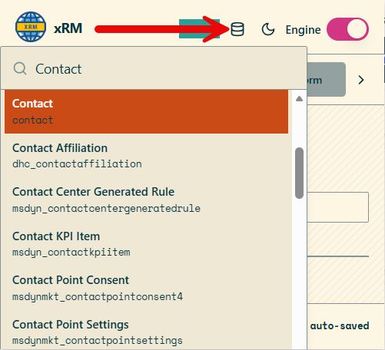
- Home
Set your default publisher you are working with. That will help in warning if accidently trying to create a component with another publisher. This helps avoiding incorrect selection of publisher in maker portal.
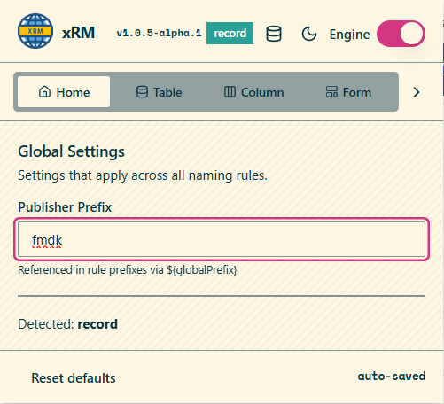
- Table
Set naming convention for creating tables.
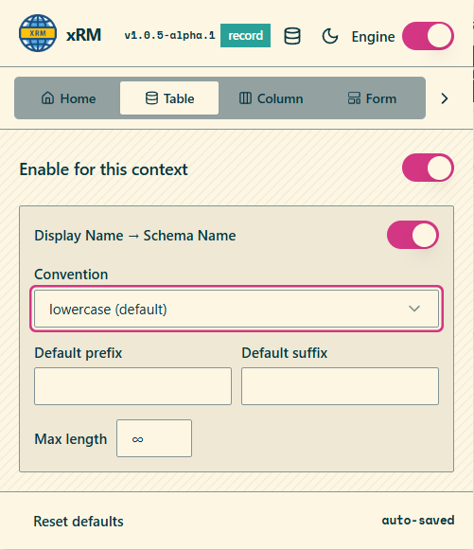
- Column
Set naming convention for a column’s different data types
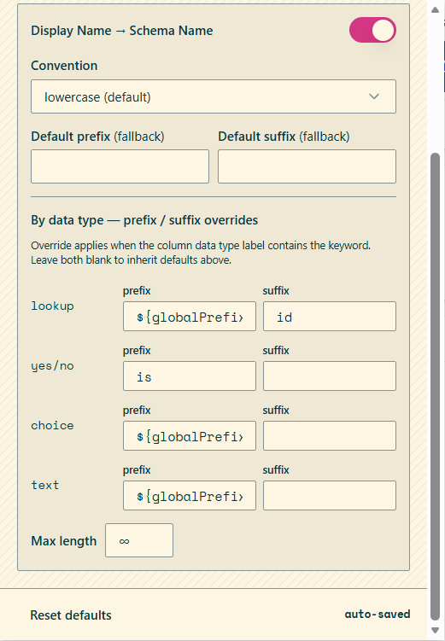
- Form
Set naming conventions for tabs, sections and subgrids.
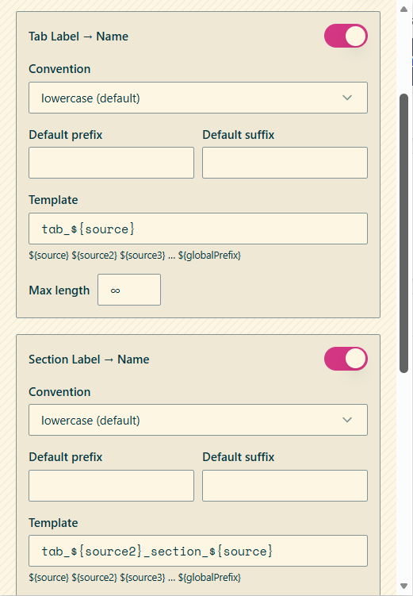
- Resource
Set naming convention for web resources
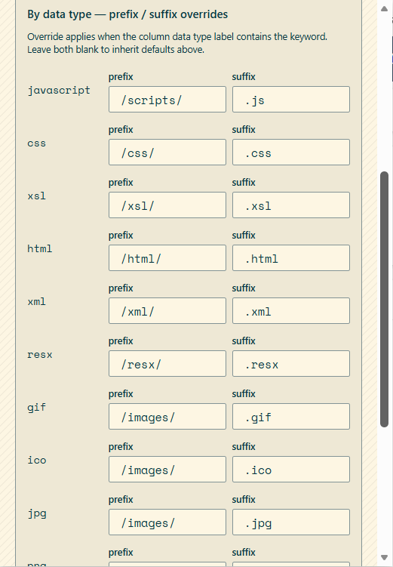
- Process
- List
>Metadata Tools for the current view entity (ALT+M)
- Record
>Metadata Tools for the current record entity (ALT+M)
Productivity tools that gives makers instant powers when a record is opened.
Templates can be set for persistent testing. Saving a form values in a template to apply on the next test record.
Persistent god mode or logical names without extra clicks to browser extension.
Shortcuts
  - ALT+F = Set fake value on a specific record or fake the full form (great for testing)
  - ALT+F+N = Set fake values in a new record (great for testing)
  - ALT+G = God mode
  - ALT+N = Logical name toggler (shows/hides logical names on fields)
  - ALT+C = Clone record
  - ALT+I = Copy ID
Metadata tools
- Json object manipulator
Shows an editor with the record properties and values to easily change values, create templates, randomize values and explore metadata.
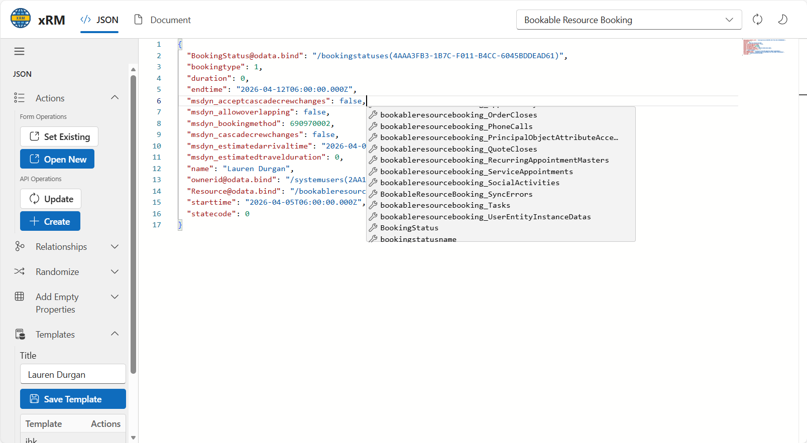
- Documentation tools
  - Form documentation listing fields with extra information like related workflows cross referenced with form attribute form. Filter on form fields with advanced metadata filtering
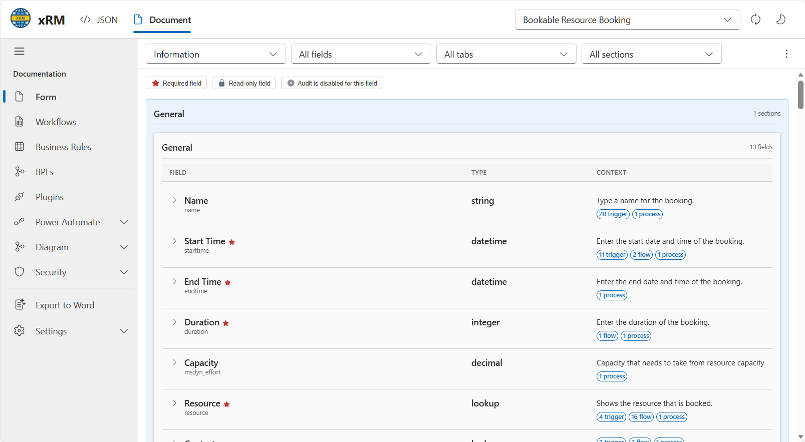
  - Workflows (business rules, business process flows, plugins and power automate flows)
Shows workflows that triggers on that table and attributes.
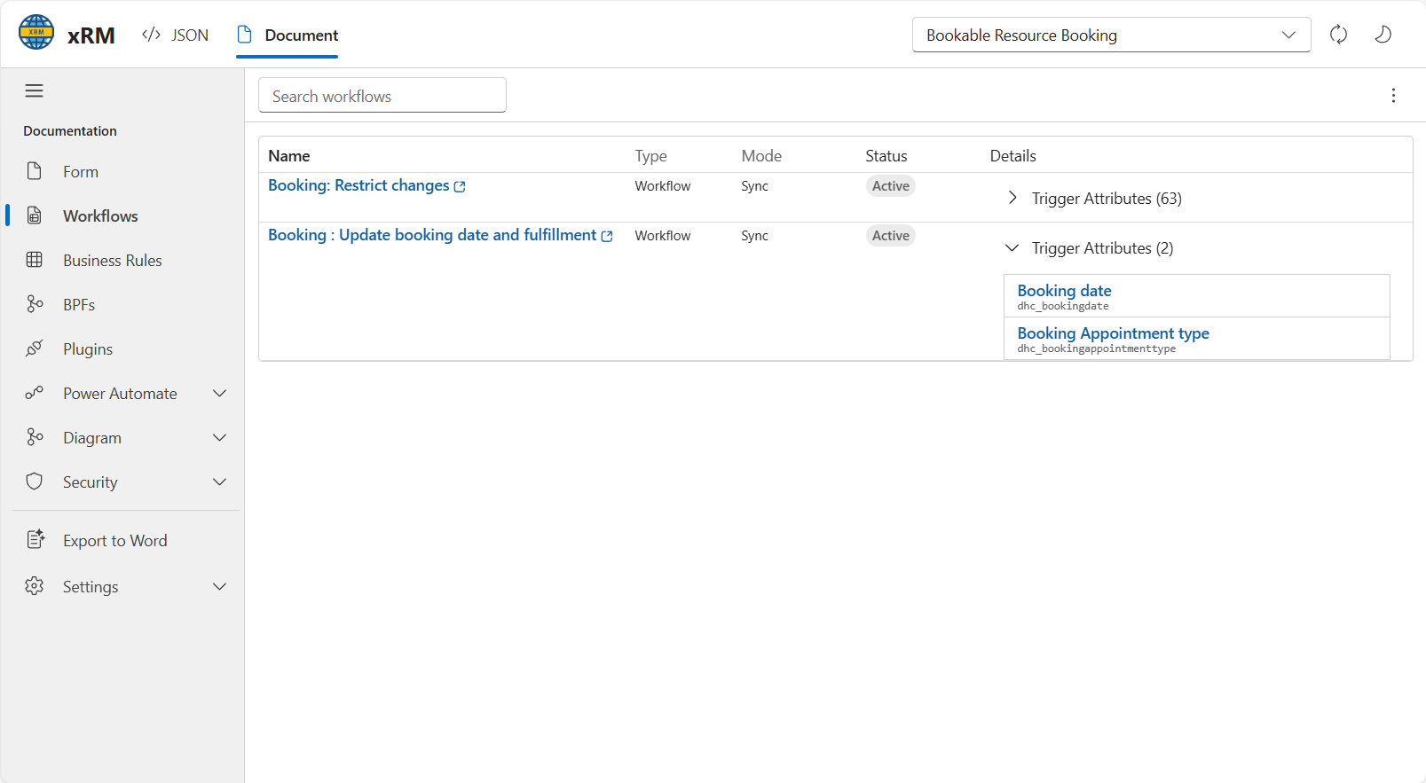
  - Diagrams for Relationships and Automations
Show relationships selected in mermaid flow chart
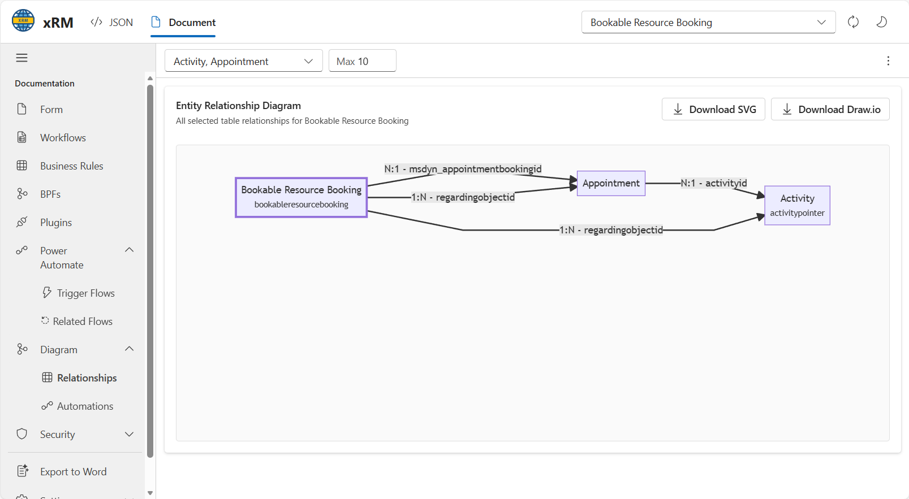
  - Security roles for the table and the ability to filter by user and/or specific security level.
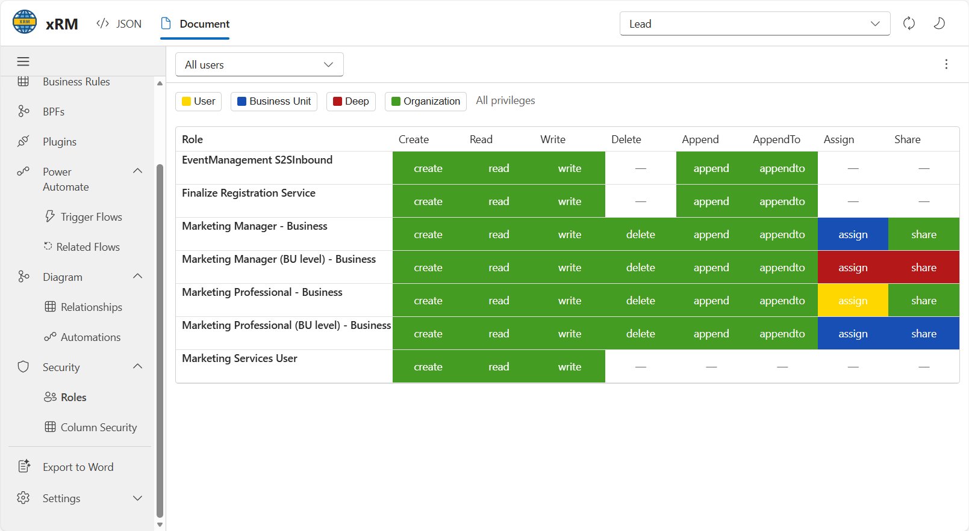
  - Export to word document
Can export a full word document with all the metadata incormation.

